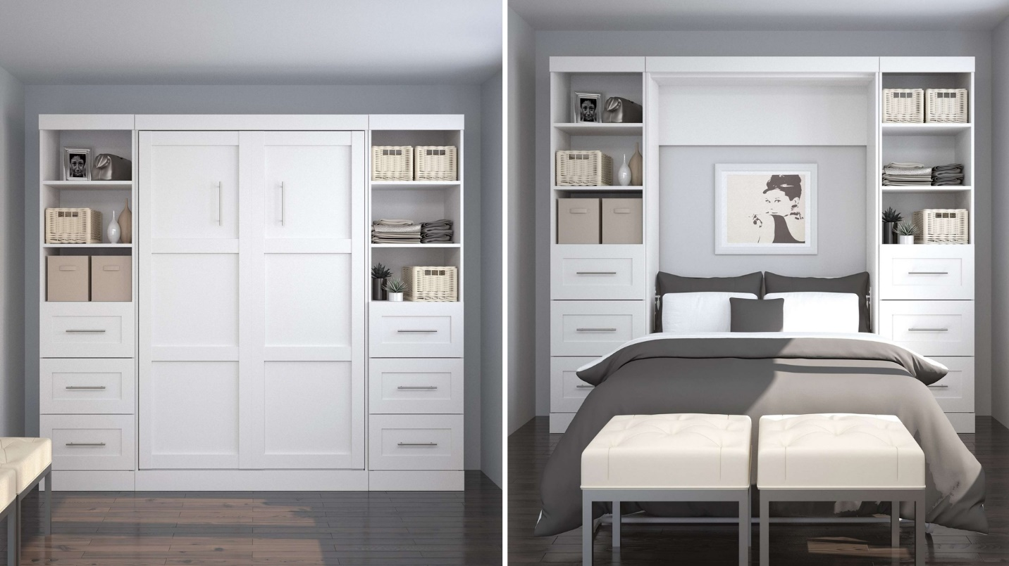

|  |  |
| --- | --- |
| **Title** | Full Wall Bed Kit with 3 Drawers |
| **Size** | 2.1 m long ; 1.9 m wide; 1.9 high |
| **Weight** | 130 kg |
| **Price** | $2,499.00 |